Samuel Ogunfunmi

Assignment Description: Show how these modifications change the behavior and output of your first program (HelloWorld)

Assignment Due Date: 08/28/20

**PART 1**

1. **Algorithm (Solution Plan for the Problem):**

1. Capitalize the print command. What type of error does it generate?
   1. We are given a syntax error because the print command is capitalized instead of lowercase
2. Mix the quotation types around the text. What error message do you get?
   1. “EOL while scanning string literal”
3. What happens if you leave out the quotes around the string of text?
   1. You will get an invalid syntax error.
4. What happens if you leave out the closing parentheses? What error message does it generate?
   1. You will get an invalid syntax error.
5. Add a print statement with 2 new strings separated by commas: Your favorite food and a Short message to Professor Ferguson
   1. My favorite food is Pizza, I like this class
6. How would you print a quoted phrase or text? Example: Isn't Python Great?
   1. You would type the quote in call symbols. Example: ‘Isn't Python Great’
7. How do you print parts of the statement on two lines?
   1. You can print parts of the statement on two lines by using

\n where you want to separate the statement.

1. Include the result of the addition of 3 numbers as arguments to a new print statement.
   1. print (1+2+3) displays the result of the addition of 3 numbers

**2. Program Source Code (copy and paste from IDE):**

**1)**

def main(): #Function header

#Capitalize the print command. What type of error does it generate?

print("Capitalize the print command. What type of error does it generate?")

PRINT("Hello World")

main() #invoking the function by calling it using its name

**2)**

def main(): #Function header

#Mix the quotation types around the text. What error message do you get?

print("Mix the quotation types around the text. What error message do you get?")

print('Hello World")

main() #invoking the function by calling it using its name

**3)**

def main(): #Function header

#What happens if you leave out the quotes around the string of text?

#Will the the string Hello world! be displayed? If not what type of error do you get?

print(Hello World)

main() #invoking the function by calling it using its name

**4)**

def main(): #Function header

#What happens if you leave out the closing parentheses?

#What error message does it generate?

print("Hello World"

main() #invoking the function by calling it using its name

**5)**

def main(): #Function header

#Add a print statement with 2 new strings separated by commas:

#Favorite food and a short message to Professor Ferguson

print("My favorite food is Pizza, I like this class")

main() #invoking the function by calling it using its name

**6)**

def main(): #Function header

#How would you print a quoted phrase or text? Example: Isn't Python Great?

print("'Isn't Python Great?'")

main() #invoking the function by calling it using its name

**7)**

def main(): #Function header

#How do you print parts of the statement on two lines?

print(" How do you print parts of the statement \n on two lines?")

main() #invoking the function by calling it using its name

**8)**

def main(): #Function header

#Include result of addition of 3 numbers as arguments to a new print statement.

print(1+2+3)

main() #invoking the function by calling it using its name

**3. Program Output Screenshots/Screen Print(s) and/or Error Messages:**

**1)**

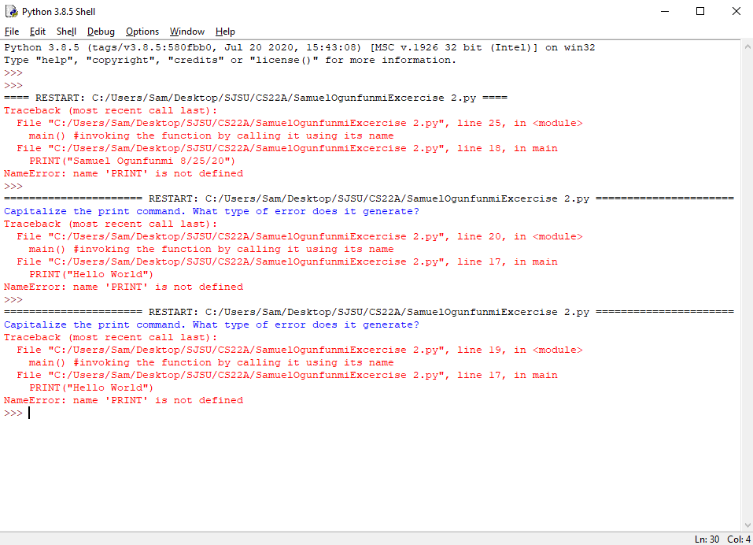

**2)**

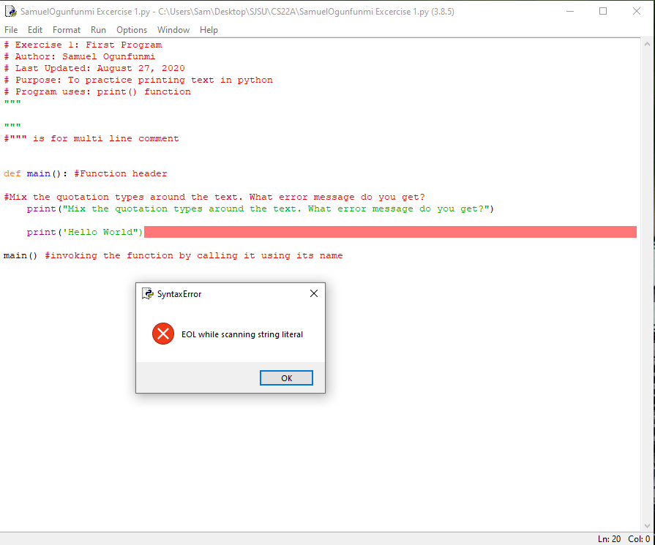

**3)**

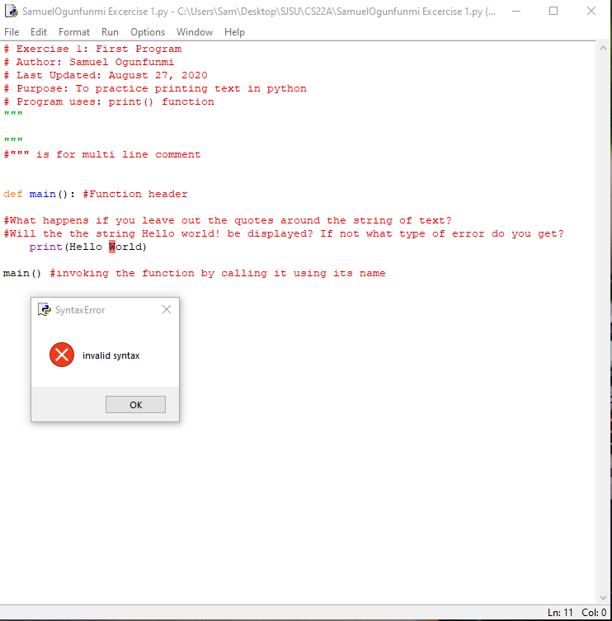

**4)**

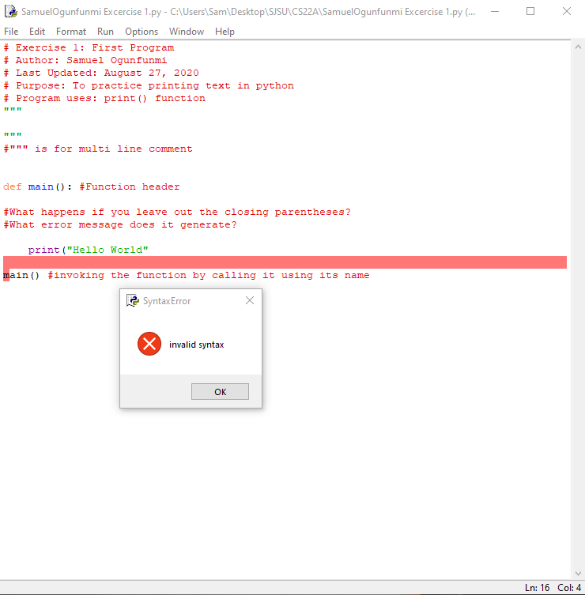

**5)**

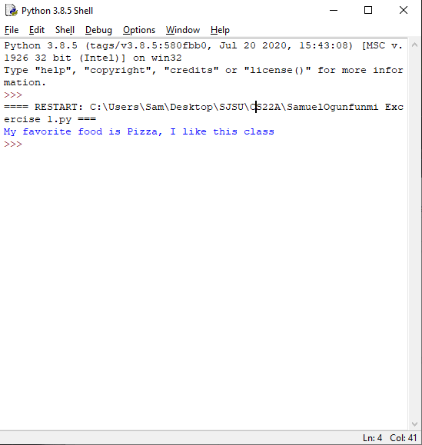

**6)**

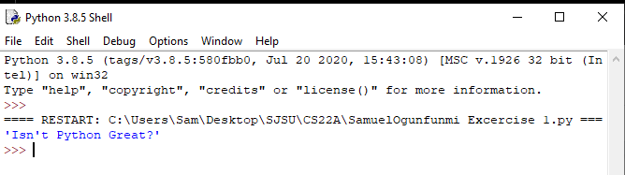

**7)**

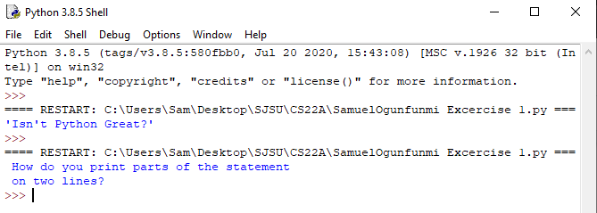**8)**

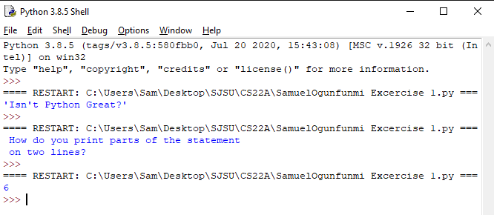

**PART 2**

1. **print (“My name is __________ “\n) #Note that \n is an escape sequence for newline**
   1. \n needs to be within the quotation marks.

**Input**

def main(): #Function header

#ORIGINAL

# print (“My name is __________ “\n)

#DEBUGGED

print ("My name is __________ \n") #\n must be within the quotation marks.

#Quotations also edited to face the right way.

main() #invoking the function by calling it using its name

**Output**

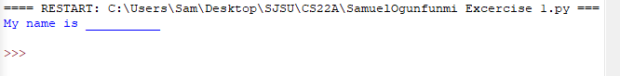

1. **print("a“ 7);**
   1. The Semicolon and the 7 need to be within the parenthesis and quotation marks

**Input**

def main(): #Function header

#ORIGINAL

# print("a“ 7);

#DEBUGGED

print("a 7;") #Moved the semicolon and 7 within the parenthesis and quotation marks

main() #invoking the function by calling it using its name

**Output**



1. **print(1, "b);**
   1. Added a quotation mark in front of 1 and moved b and the semicolon and parenthesis and quotation marks.

**Input**

def main(): #Function header

#ORIGINAL

# print(1, "b);

#DEBUGGED

print("1, b;") #Added a quotation mark in front of 1.

#Moved b and the semicolon and parenthesis and quotation marks.

main() #invoking the function by calling it using its name

**Output**



1. **print(2, "c", 3);**
   1. Move the quotation marks to the outside of 2 and 3. Semicolon moved to be inside the quotation marks.

**Input**

def main(): #Function header

#ORIGINAL

# print(2, "c", 3);

#DEBUGGED

print("2, c, 3;") #Move the " " to the outside of 2 and 3.

#Moved ; to be inside the quotation marks.

main() #invoking the function by calling it using its name

**Output**



1. **Print “F", 5**
   1. Make P lowercase. Move the right quotation mark to the right side of 5. Add parenthesis outside of both quotation marks

**Input**

def main(): #Function header

#ORIGINAL

# Print “F", 5

#DEBUGGED

print ("F, 5") #Move the " " to the outside of 2 and 3.

# Make P lowercase.

# Move right quotation mark to the right side of 5.

# Add parenthesis outside of both quotation marks

main() #invoking the function by calling it using its name

**Output**

